NAME : BHAVYANSH

SHARMA

REG NO.: 19BCE1282 MATLAB lab 3

Date: 22.02.2021

**Solve the equations 1−3**

**1. 𝑦′′−𝑦′−2𝑦=4𝑥2**

**2. 𝑦′′−𝑦′−2𝑦=𝑒3𝑥**

**3. 𝑦′′−𝑦′−2𝑦=siN2𝑥**

**For each of the question take y(0)=1 and y(1)=0**

**•Modify the program in such a way that you can give the conditions y(0)=1 and y'(0)=2 .**

CODE:

**Modified:**

clc clear all close all

syms x r c1 c2

p1=input('Enter the coefficient of D2y:'); p2=input('Enter the coefficient of Dy:'); p3=input('Enter the coefficient of y:'); eq=p1*r^2+p2*r+p3; %auxiliary equation r=solve(eq,r); %solve for 'r' in 'eq' and store in 'eq' p=real(r(1)); %real part of r(1)

q=imag(r(1)); %imaginary part of r(1) if q~=0 % complex roots y1=exp(p*x)*cos(q*x); y2=exp(p*x)*sin(abs(q)*x);

elseif r(1)==r(2) % real and equal roots

y1=exp(r(1)*x); y2=x*exp(r(1)*x);

else % real and distinct roots y1=exp(r(1)*x);

y2=exp(r(2)*x); end

y_c=c1*y1+c2*y2 %complementary function W=simplify(y1*diff(y2)-y2*diff(y1));

%Wronskian(y1,y2)-refer to rough notes f=input('Enter the non homogeneous part:');

y_p=-y1*int(y2*f/W)+y2*int(y1*f/W); %Refer to rough notes y=simplify(y_c+y_p) %general soln

disp('The general solution of the given ODE is') disp(y)

%IVP

a=input('Enter the value of a:'); b=input('Enter the value of b:'); c=input('Enter the value of y(a):'); d=input('Enter the value of y(b):');

eq1=subs(y,x,a)-c; %substitute occurences of x in y with a

eq2=subs(diff(y),x,b)-d;

[c1,c2]=solve(eq1,eq2); y_total=subs(y);

disp('The general solution of the given boundary problem is')

disp(y_total)

ezplot(y_total) %plotting general solution within a and b

**1. 𝑦′′−𝑦′−2𝑦=4𝑥2**

graph:

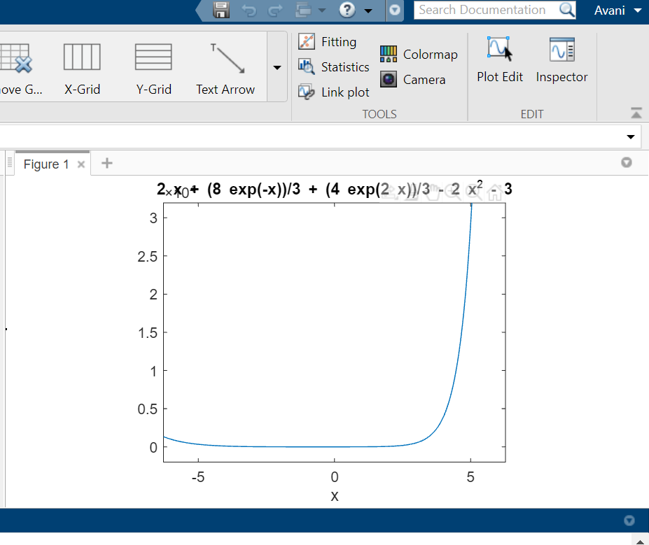

Command window:

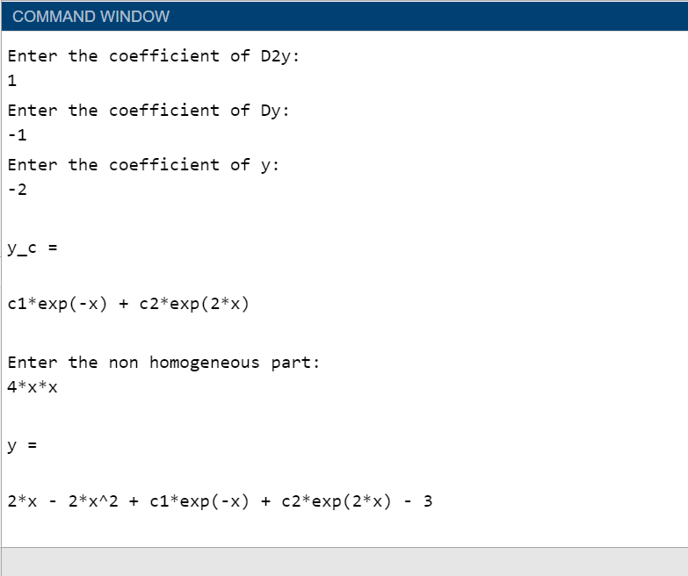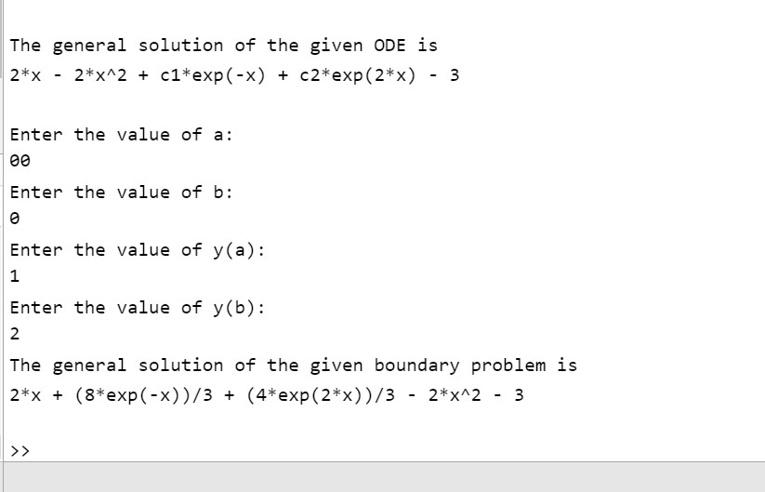

**2. 𝑦′′−𝑦′−2𝑦=𝑒3𝑥**

Graph:

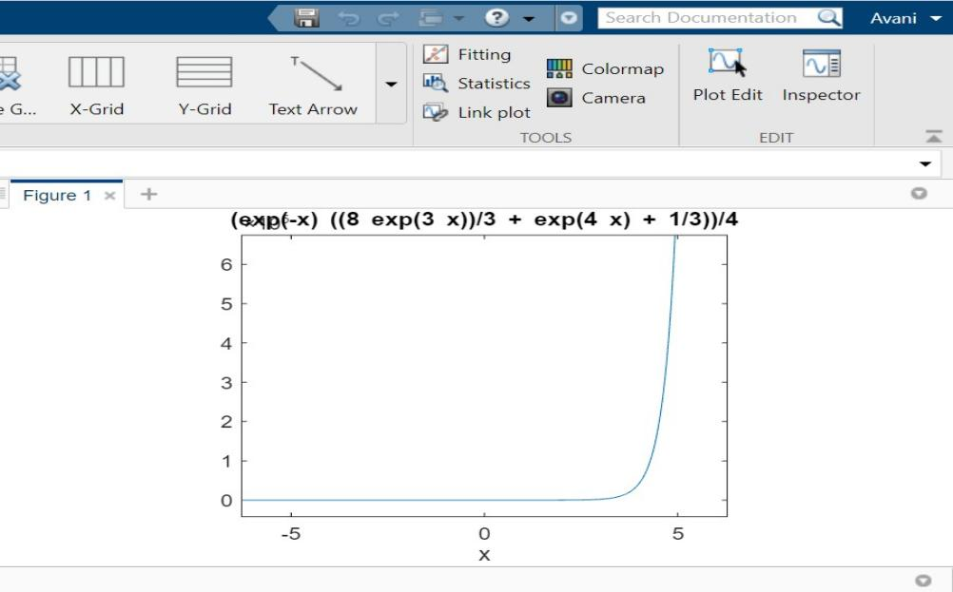

Command window:

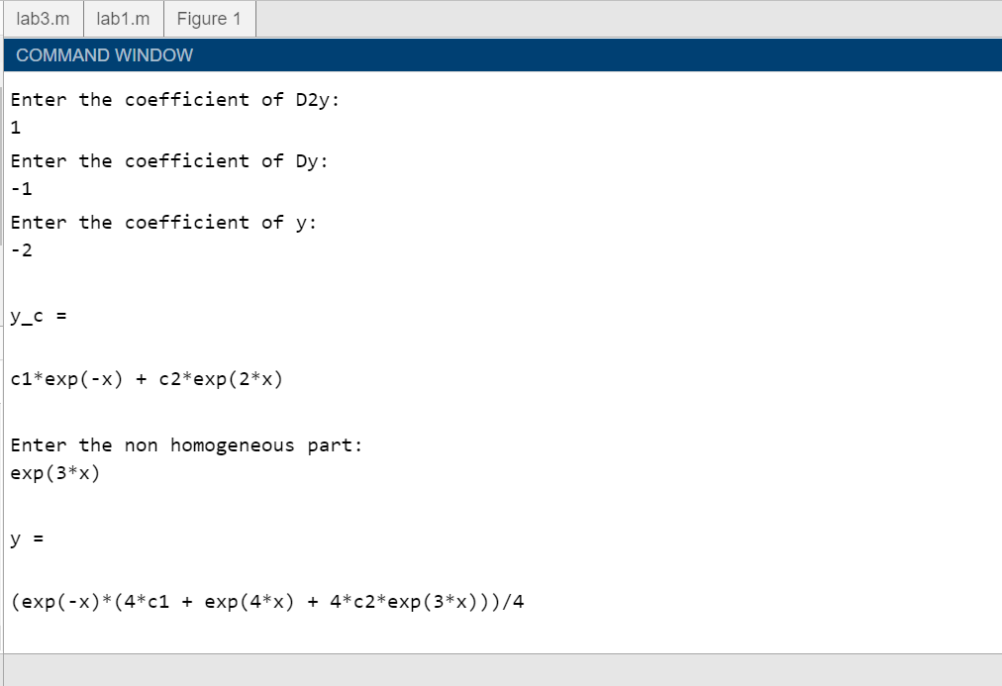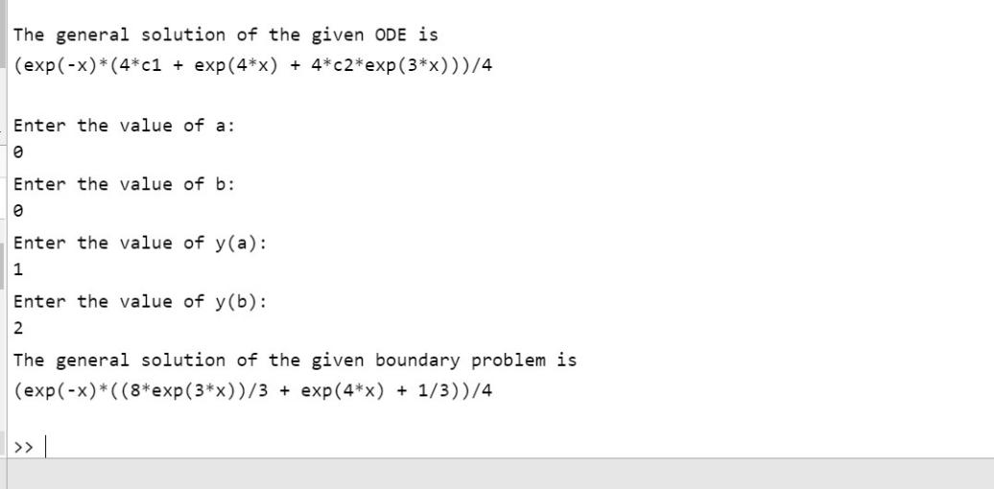

**3. 𝑦′′−𝑦′−2𝑦=sin2𝑥**

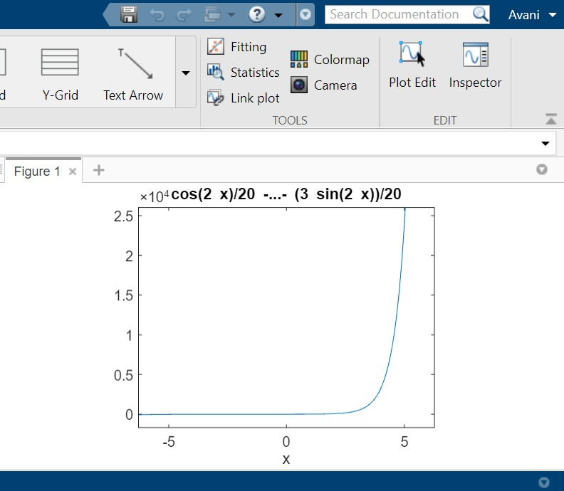

Command window:

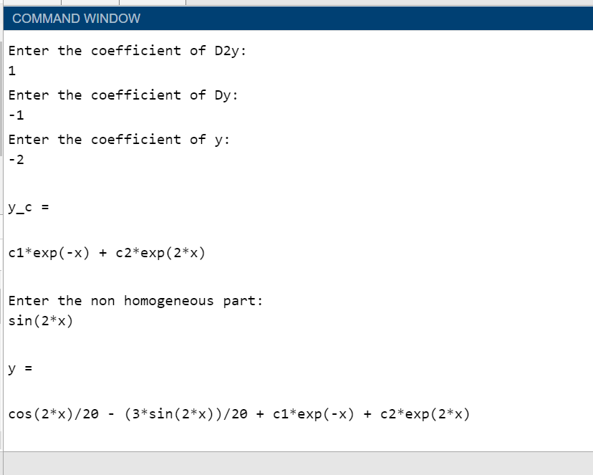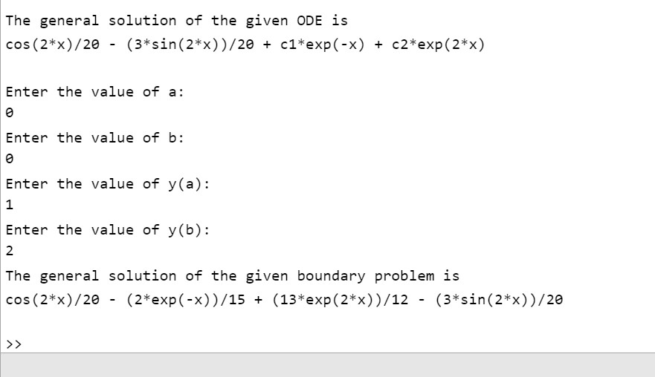

**UNMODIFIED:**

clc clear all close all

syms x r c1 c2

p1=input('Enter the coefficient of D2y:'); p2=input('Enter the coefficient of Dy:'); p3=input('Enter the coefficient of y:'); eq=p1*r^2+p2*r+p3; %auxiliary equation r=solve(eq,r); %solve for 'r' in 'eq' and store in 'eq' p=real(r(1)); %real part of r(1)

q=imag(r(1)); %imaginary part of r(1) if q~=0 % complex roots y1=exp(p*x)*cos(q*x); y2=exp(p*x)*sin(abs(q)*x);

elseif r(1)==r(2) % real and equal roots y1=exp(r(1)*x);

y2=x*exp(r(1)*x);

else % real and distinct roots y1=exp(r(1)*x);

y2=exp(r(2)*x); end

y_c=c1*y1+c2*y2 %complementary function

W=simplify(y1*diff(y2)-y2*diff(y1)); %Wronskian(y1,y2)-refer to rough

notes

f=input('Enter the non homogeneous part:');

y_p=-y1*int(y2*f/W)+y2*int(y1*f/W); %Refer to rough notes y=simplify(y_c+y_p) %general soln

disp('The general solution of the given ODE is')

disp(y)

%IVP

a=input('Enter the value of a:'); b=input('Enter the value of b:'); c=input('Enter the value of y(a):'); d=input('Enter the value of y(b):');

eq1=subs(y,x,a)-c; %substitute occurences of x in y with a eq2=subs(y,x,b)-d;

[c1,c2]=solve(eq1,eq2); y_total=subs(y);

disp('The general solution of the given boundary problem is')

disp(y_total)

ezplot(y_total,[a,b]) %plotting general solution within a and b

**1. 𝑦′′−𝑦′−2𝑦=4𝑥2**

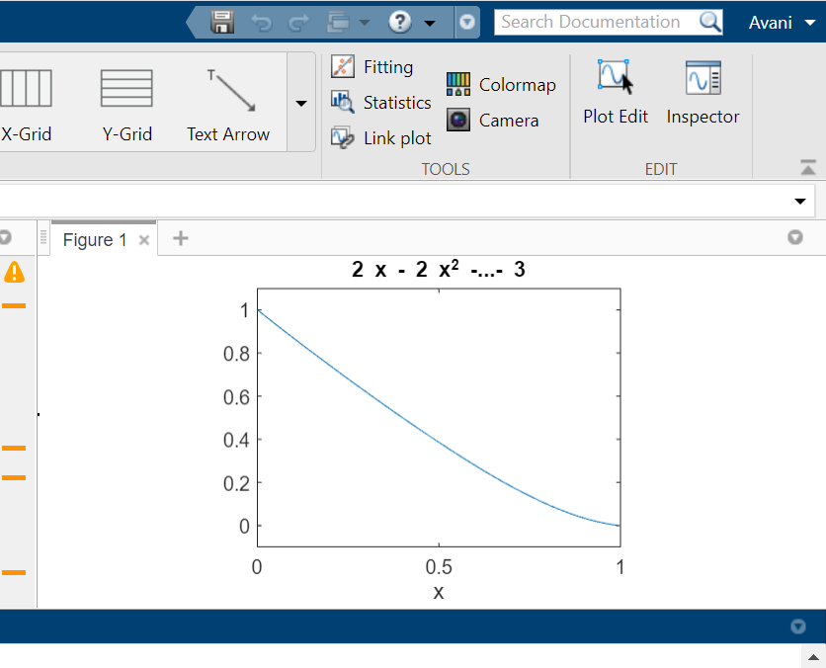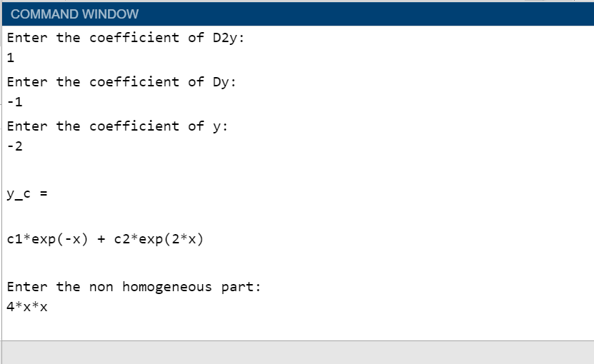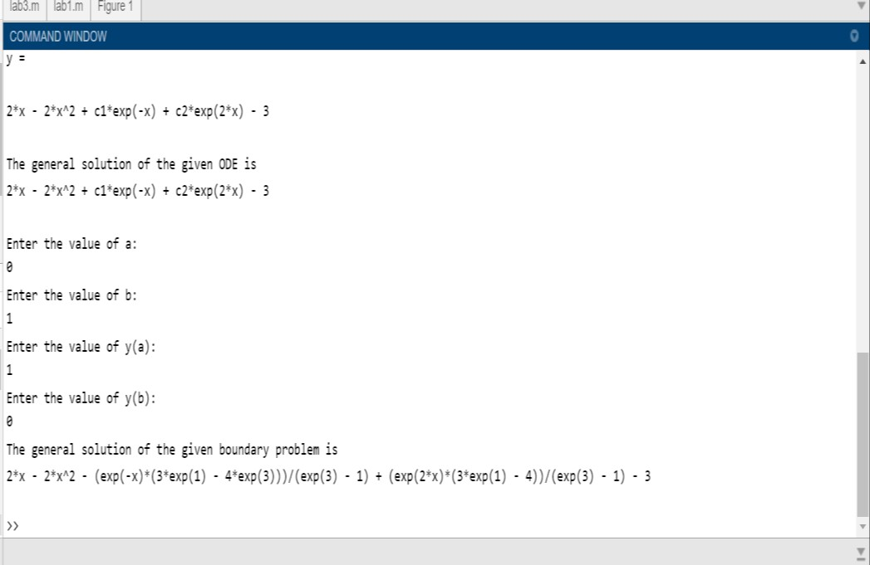

**2. 𝑦′′−𝑦′−2𝑦=𝑒3𝑥**

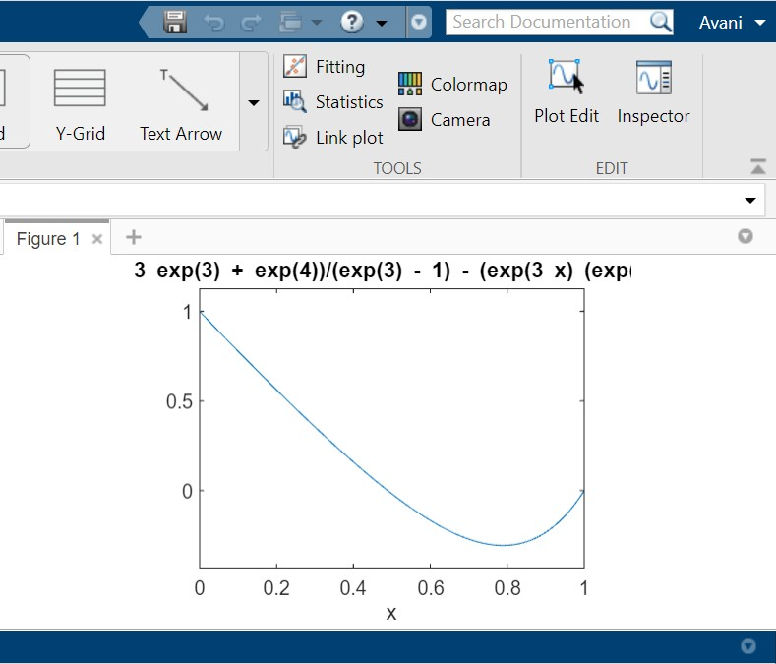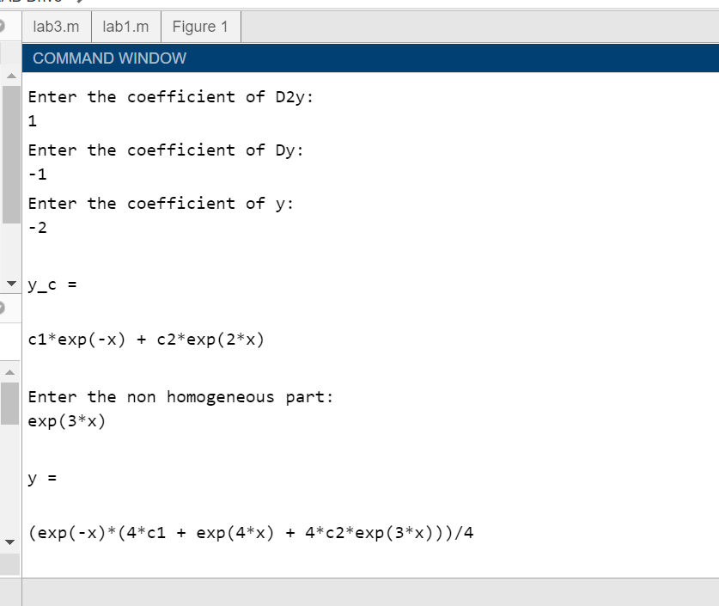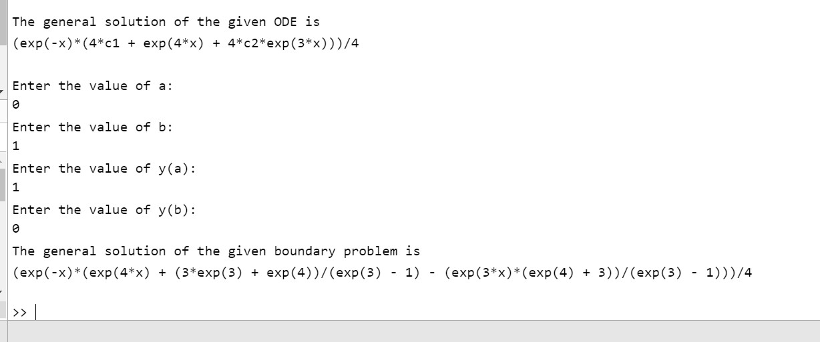

**3. 𝑦′′−𝑦′−2𝑦=sin2𝑥**

